resident leadership academy –  - facilitator seminar  What: Community leaders and community-based organization staff will gain knowledge and skills to facilitate their own Resident Leadership Academy (RLA). RLAs are an authentic way to engage residents to bring positive changes to neighborhoods. RLAs provide powerful leverage to realize healthy, safe and thriving lives for all.  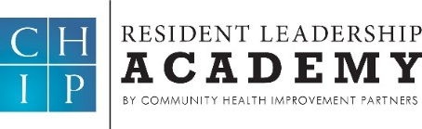  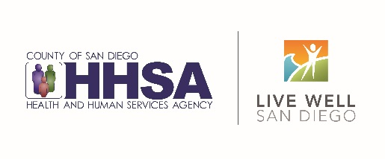  Who: We are inviting local leaders and community-based organization staff who are passionate and already active in improving low-resourced communities in San Diego. Every participant is expected to make a commitment to initiate an RLA soon after the training is completed.  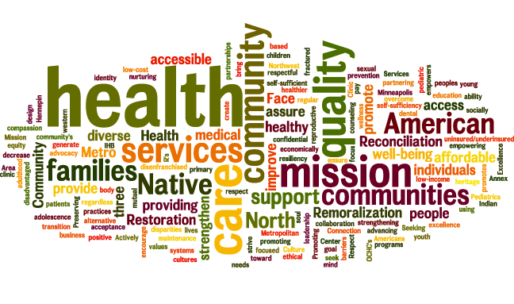  Goal: Upon completion of this free non-consecutive, 4-day intensive training, you and your organization will be poised to implement a community-based Resident Leadership Academy (RLA). | Coming This Spring 2018!  Learn how to build leaders in your community!  Space is Limited!  Reserve Your Spot Today!  For more information:  Yeni L. Palomino at ypalomino@sdchip.org or 858-609-7969  SPRING SCHEDULE  THURSDAY 2.15.18  WEDNESDAY 2.21.18  FRIDAY 3.2.18  WEDNESDAY 3.7.18  TIME  9am-4pm  LOCATION  ME Forensic Center  Training Room  5570 Overland Ave, SD

What Do I Have to Do? Send an email indicating interest and attach the completed form and resume (resume is optional) to Yeni L. Palomino at ypalomino@sdchip.org.

Seminar for Facilitators of
Resident Leadership Academies

Candidates Name
Organization Where You Work or Organization You are Participating on Behalf of (if applicable)

Email Address
Mailing Address
Phone Number

Commitment: Please explain why you are interested and how you will put this training to use. For example, are you planning to lead an RLA after completing this training? Please include information about any interest or plans for you to conduct an RLA from either the organization where you work or an organization with which you are affiliated.

