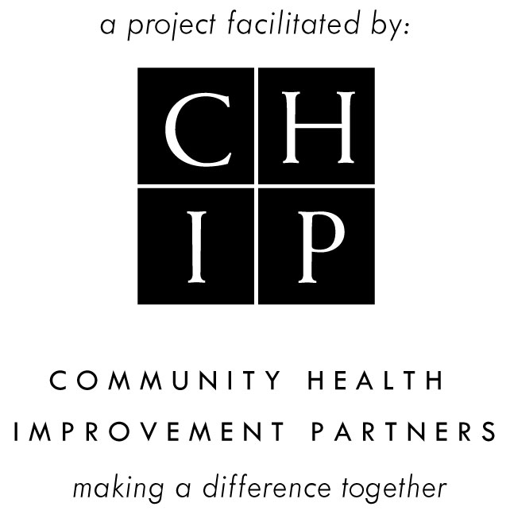
SAN DIEGO COUNTY SUICIDE PREVENTION COUNCIL (SPC) MEETING - AGENDA
Tuesday, July 24, 2018
10:00 am – 11:30 am
American Red Cross
(3950 Calle Fortunada San Diego, CA 92123)

Our Mission: To prevent suicide and its devastating consequences in San Diego County
Our Vision: Zero Suicides in San Diego County

- Welcome/Introductions 10:00am Beth Sise/Carol Skiljan

- SPC Overview/Updates 10:10am Yeni L. Palomino

- SPC Subcommittees Updates 10:20am Yeni L. Palomino
  - Faith Organization Outreach (Lora Cayanan, SPC/CHIP Staff)
  - Higher Education (Lora Cayanan, SPC/CHIP Staff)
  - Media (Yeni L. Palomino, SPC/CHIP Staff)
  - Assessment + Evaluation (Beth Sise, Subcommittee Chair)
  - School Collaborative K-12 (Judi Park, Subcommittee Chair

- Upcoming Events 10:35am Yeni L. Palomino

- Spotlight Presentation- 10:45am Lisa Garcia
  - Recovery International
  - Lisa Garcia, Project Manager
    - Panelists: Judi Bakke, Nancy Campbell, and Nancy Reves

- Announcements 11:25am Carol Skiljan/All

- Adjournment 11:30am All

Next SPC Meeting
Tuesday, August 28, 2018, 10:00am-11:30am @ American Red Cross
(Email: Kim McGee to RSVP kmcgee@sdchip.org)

Upcoming Subcommittee Meetings:

SPC Higher Education Subcommittee
Wednesday, August 1, 2018, 10:00am-11:00am
Conference Call
(To RSVP email kmcgee@sdchip.org)

SPC JOINT Media/A+E/School Collaborative Subcommittee Meeting
Wednesday, August 8, 2018, 1:30pm-3:00pm
(To get meeting information email kmcgee@sdchip.org)

SPC Faith Outreach Subcommittee
Wednesday, August 15, 2018, 11:00am-12:30pm
(To RSVP email kmcgee@sdchip.org)

SPC Tools:
SPC 3-Year Strategic Work Plan; SPC Charter; SPC Elevator Pitch
SPC Flyer; SPAP & SPC Standard Presentation;
San Diego County Responsible Reporting on Suicide Guidelines
SPAP & SPC Sample Newsletter Text; SPC 2011 Activities
www.spcsandiego.org

Suicide Prevention Action Plan
www.up2sd.org/find-help/resources/suicide-prevention-and-support
www.sdchip.org/committee/publications.aspx

Question, Persuade, and Refer (QPR) Gatekeeper Trainings for Suicide Prevention
FREE 1 HOUR TRAINING JUST CALL TO SCHEDULE
www.sdchip.org/suicide-prevention-training.aspx
To schedule training(s): Contact Lora Cayanan at 858-609-7971 or lcayanan@sdchip.org.

Upcoming Events and Dates of Interest:

UMTR2ME- Hike for Hope
Saturday, July 28, 2018, 9:00am-11:30am
San Dieguito Lagoon Staging Area
(For more information: info@umtr2me.org)
(Please RSVP at https://www.eventbrite.com/e/hike-for-health-tickets-47316581168?aff=efeventtix)
AFSP Talk Saves Lives Training
Saturday, July 28, 2018, 10:00am-11:30am
Sharp Outpatient Pavilion
(For more information: whitneybaugher@gmail.com)

QPR Training LGBTQ
Friday, August 10, 2018, 6:00pm-7:30pm
North County LGBTQ Resource Center 6-7:30pm
(For more information: Max Disposti at maxrome@cox.net)

Alzeheimer’s Assocation: The Latest Discoveries, A Research Update
Tuesday, August 15, 2018, 6:00pm-8:00pm
Shiley Theatre at Camino Hall, University of San Diego
5998 Alcala Park, SD 92110
(For more information: 1-800-272-3900)

Kobey’s NON PROFIT DAY
Saturday, August 18, 2018, 7:00am-3:00pm
Kobeys Swap Meet (3500 Sports Arena Blvd., SD 92110)
(For more information: apretto@kobeys.com; 619-523-2700x306)

SPC Suicide Prevention Action Plan Update 2018
Implementation + Evaluation Planning Meeting
Means Reduction Strategy
Monday, August 20, 2018, 2:00pm-4:30pm
Jacobs Center (Emerald Hills Room)
404 Euclid Ave, SD 92114
*Light refreshments and Spanish interpretation provided*
(For more information: lcayanan@sdchip.org or 858-609-7971)
(Please RSVP at (https://bit.ly/2Ld2PKv)
SPC Suicide Prevention Action Plan Update 2018
Implementation + Evaluation Planning Meeting
Frontline & Gatekeeper Training Strategy
Thursday, August 23, 2018, 2:00pm-4:30pm
Jacobs Center (Emerald Hills Room)
404 Euclid Ave, SD 92114
*Light refreshments and Spanish interpretation provided*
(For more information: lcayanan@sdchip.org or 858-609-7971)
(Please RSVP at (https://bit.ly/2ugSpTT)
SPC Suicide Prevention Action Plan Update 2018
Implementation + Evaluation Planning Meeting
Community Programming Strategy
Thursday, October 25, 2018, 2:00pm-5:00pm
Paradise Point
1404 Vacation Rd, SD 92109
*Light refreshments and Spanish interpretation provided*
(For more information: lcayanan@sdchip.org or 858-609-7971)
(Please RSVP at (https://bit.ly/2LgbtYw)

Check Your Mood Event
Thursday October 11, 2018
San Diego County
For more information: www.LiveWellSD.org/CheckYourMood

San Diego County Behavioral Health Advisory Board Meeting
Thursday August 2, 2018 at 2:30pm
San Diego County Administration Building
1600 Pacific Highway, San Diego, CA (Room 302/303)

AFSP Out of the Darkness Walk 2018
Saturday October 27, 2018
8:00am-12:00pm
NTC Liberty Station (2455 Cushing Rd, SD 92106)
For more information: afsp.org/sandiegowalk
Che Hernandez, Walk Co-Chair sandiego@afsp.org AND
Danielle McGonigle, Walk Co-Chair danielle.afsp@gmail.com

SOSL in Remembrance with Hope Walk 2018
Sunday November 11, 2018
8:00am-12:00pm
Balboa Park (6th and Laurel)
For more information:
Joyce Bruggeman at Joyce@SOSLsd.org or 619-752-4055

